Skip to main content

Search Products
More from ColesAccountLists
$0.00
- Shop products
- Specials & catalogues
- Bought before
- Recipes & inspiration
- Ways to shop
- Help

Free trial

Mount Druitt
When
- Home
- Lists
- Price Compare
Price Compare
Invite others
Estimated total
$302.89
Estimated savings
$16.60
Add list to trolley
65 items
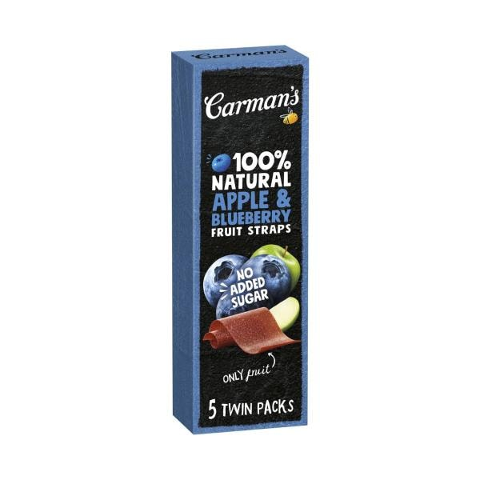
SPECIAL

Carman's Fruit Straps Apple & Blueberry | 70g

$5.40
Save $0.60
$7.71/ 100g | Was $6.00
2 more buying options
Quantity
Fruit Straps Apple & Blueberry quantity is 1 item123456789101112
Remove from list
Product is not in your trolleyAdd
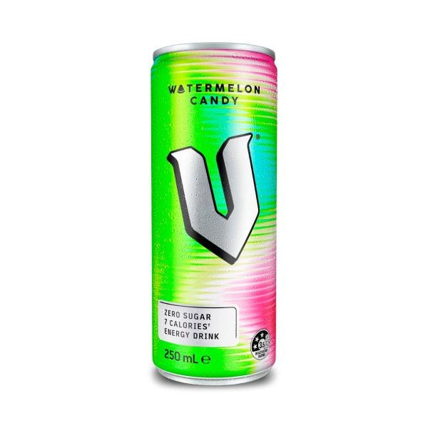

V Energy Drink Watermelon Candy | 250mL

Currently unavailable
Quantity
Energy Drink Watermelon Candy quantity is 1 item123456789101112131415161718192021222324
Remove from list
Shop similar
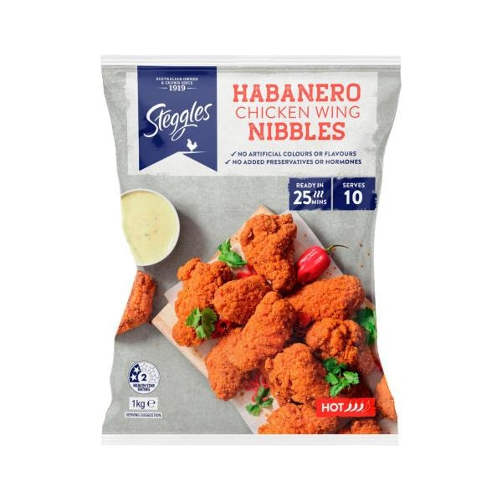
SPECIAL

Steggles Habanero Chicken Wings | 1kg

$11.00
Save $2.50
$11.00/ 1kg | Was $13.50
Quantity
Habanero Chicken Wings quantity is 1 item123456789101112
Remove from list
Product is not in your trolleyAdd
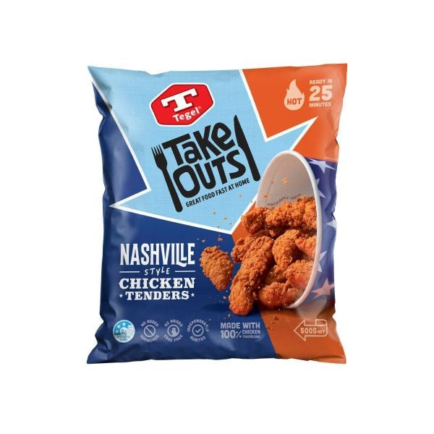

Tegel Take Outs Frozen Chicken Tenderloins Nashville Style | 500g

$14.00
$28.00/ 1kg
Quantity
Take Outs Frozen Chicken Tenderloins Nashville Style quantity is 1 item1234567891011121314151617181920
Remove from list
Product is not in your trolleyAdd
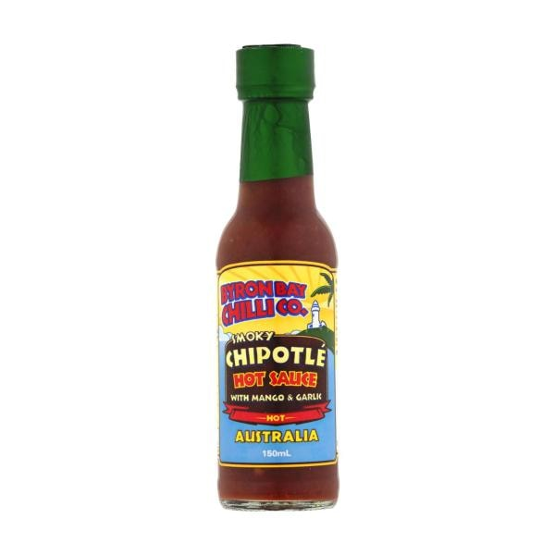

Byron Bay Chilli Co. Smoky Chipotle Hot Sauce | 150mL

$4.50
$3.00/ 100mL
Quantity
Smoky Chipotle Hot Sauce quantity is 1 item1234567891011121314151617181920
Remove from list
Product is not in your trolleyAdd
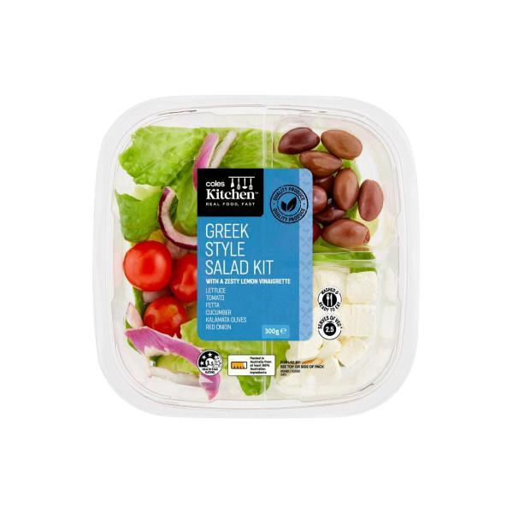

Coles Kitchen Made For Sharing Salad Kit Greek Style | 300g

$8.80
$29.33/ 1kg
Currently unavailable
Quantity
Made For Sharing Salad Kit Greek Style quantity is 1 item1234567891011121314151617181920
Remove from list
Shop similar
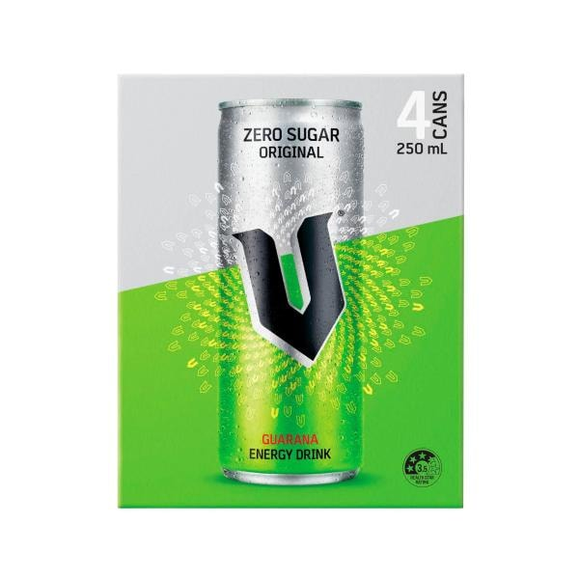
SPECIAL

V Energy Sugar Free 4x250ml | 1L

$7.20
Save $4.80
$7.20/ 1L | Was $12.00
Quantity
Sugar Free 4x250ml quantity is 1 item123456789101112
Remove from list
Product is not in your trolleyAdd

SPECIAL

Sunbites Grain Waves Chips Kids' Lunchbox Multipack 8 Pack | 176g

$6.00
$3.41/ 100g
Any 2 | $9
$2.56/ 100g
9 more buying options
Quantity
Grain Waves Chips Kids' Lunchbox Multipack 8 Pack quantity is 1 item123456789101112
Remove from list
Product is not in your trolleyAdd
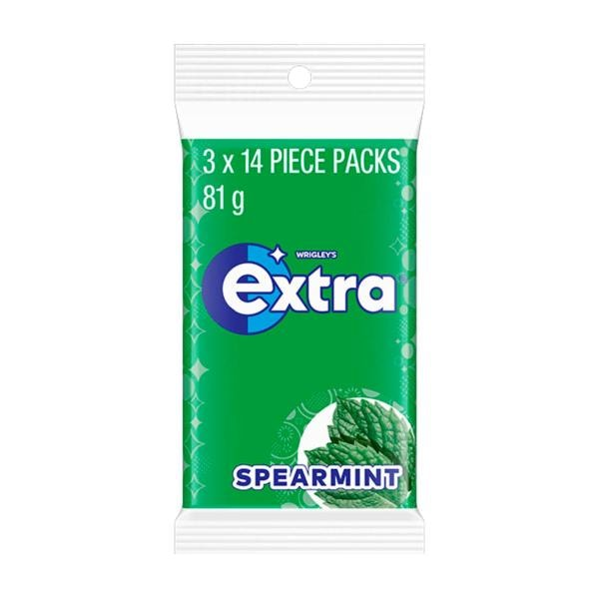
EVERY DAY

Extra Spearmint Sugar Free Chewing Gum 3x27g | 81g

$5.50
$6.79/ 100g
4 more buying options
Quantity
Spearmint Sugar Free Chewing Gum 3x27g quantity is 1 item123456789101112
Remove from list
Product is not in your trolleyAdd

SPECIAL

Coles Raspberries | 125g

$3.90
$31.20/ 1kg
1 more buying option
Quantity
Raspberries quantity is 1 item1234567891011121314151617181920212223242526272829303132333435363738394041424344454647484950
Remove from list
Product is not in your trolleyAdd

SPECIAL

Coles Strawberries | 250g

$3.00
$12.00/ 1kg
Add 2 | $5
$10.00/ 1kg
1 more buying option
Quantity
Strawberries quantity is 1 item1234567891011121314151617181920212223242526272829303132333435363738394041424344454647484950
Remove from list
Product is not in your trolleyAdd
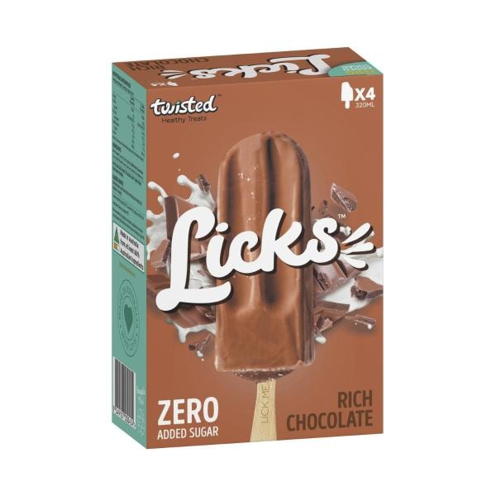
SPECIAL

Twisted Healthy Treats Rich Choc Sticks Licks Zero 4 Pack | 320mL

$8.50
Save $1.00
$2.66/ 100mL | Was $9.50
Quantity
Rich Choc Sticks Licks Zero 4 Pack quantity is 1 item123456789101112
Remove from list
Product is not in your trolleyAdd

Sunny Queen Free Range Extra Large Eggs 12 Pack | 700g

$8.80
$1.26/ 100g
Quantity
Free Range Extra Large Eggs 12 Pack quantity is 1 item1234567891011121314151617181920
Remove from list
Product is not in your trolleyAdd
Bonus entry^See footnote
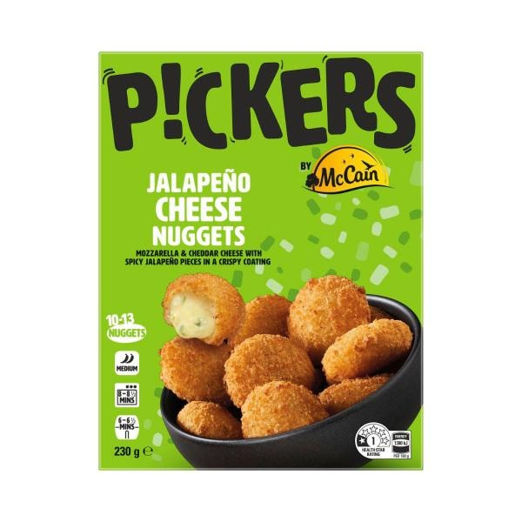

Pickers Jalapeno Cheese Nugget | 230g

$7.50
$3.26/ 100g
5 more buying options
Quantity
Jalapeno Cheese Nugget quantity is 1 item123456789101112
Remove from list
Product is not in your trolleyAdd

Coles Blueberries | 125g

Currently unavailable
Quantity
Blueberries quantity is 1 item123456789101112131415161718192021222324
Remove from list
Shop similar

EVERY DAY

Farmers Union Greek Style Natural Yoghurt | 1kg

$7.50
$0.75/ 100g
5 more buying options
Quantity
Greek Style Natural Yoghurt quantity is 1 item123456789101112
Remove from list
Product is not in your trolleyAdd

SPECIAL

Coles Free Range Eggs 12 Pack | 700g

$5.50
Save $1.00
$0.79/ 100g | Was $6.50
2 more buying options
Quantity
Free Range Eggs 12 Pack quantity is 1 item123456789101112
Remove from list
Product is not in your trolleyAdd
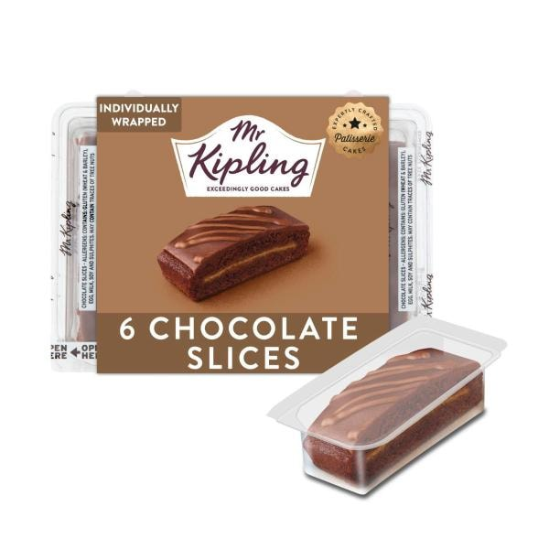

Mr Kipling Chocolate Cake Slices 6 Pack | 155g

$6.20
$4.00/ 100g
Quantity
Chocolate Cake Slices 6 Pack quantity is 1 item1234567891011121314151617181920
Remove from list
Product is not in your trolleyAdd
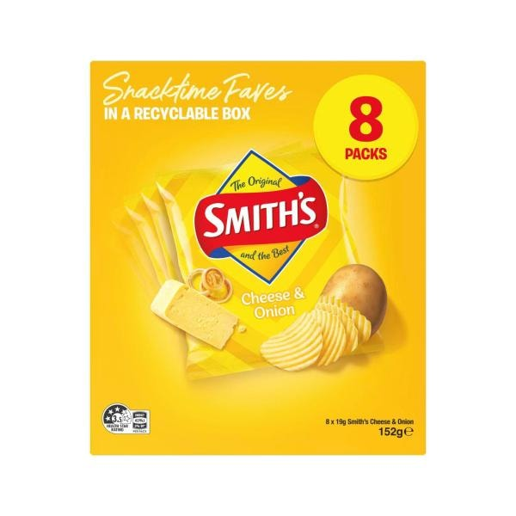
SPECIAL

Smith's Potato Chips Lunchbox Multipack Cheese & Onion 8 Pack | 152g

$6.00
$3.95/ 100g
Any 2 | $9
$2.96/ 100g
9 more buying options
Quantity
Potato Chips Lunchbox Multipack Cheese & Onion 8 Pack quantity is 1 item123456789101112
Remove from list
Product is not in your trolleyAdd
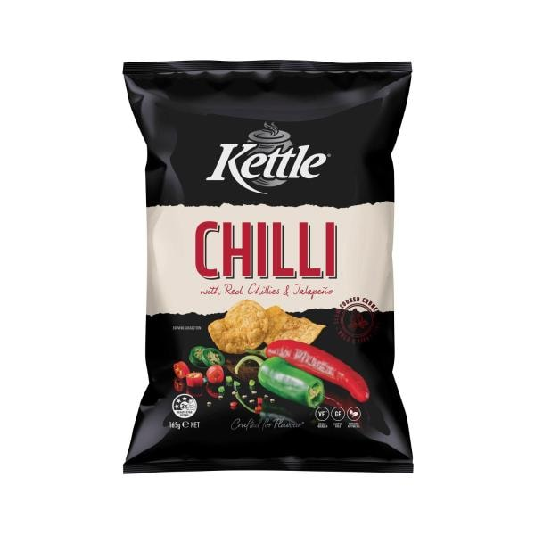
EVERY DAY

Kettle Chilli Potato Chips | 165g

$3.60
$2.18/ 100g
7 more buying options
Quantity
Chilli Potato Chips quantity is 1 item123456789101112
Remove from list
Product is not in your trolleyAdd
Bonus entry^See footnote
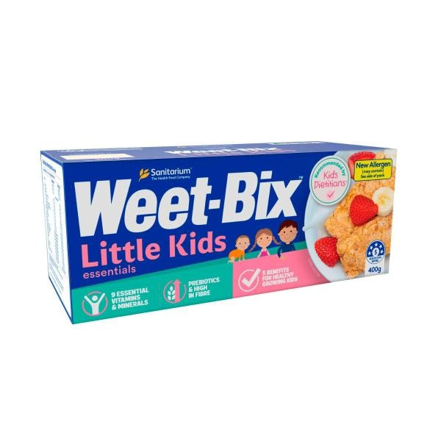

Sanitarium Weet-bix Little Kids Essentials Breakfast Cereal | 400g

$5.00
$1.25/ 100g
Quantity
Weet-bix Little Kids Essentials Breakfast Cereal quantity is 1 item123456789101112
Remove from list
Product is not in your trolleyAdd
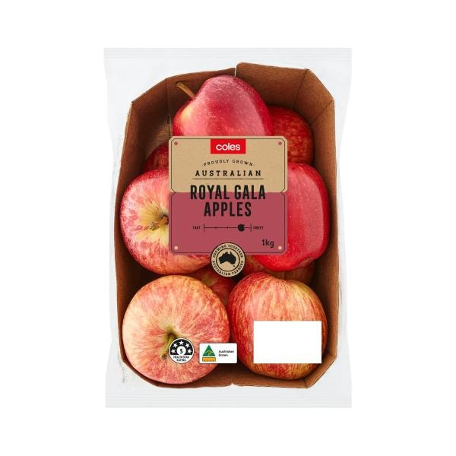

Coles Royal Gala Apples 1kg | 1 each

$7.90
$7.90/ 1kg
Quantity
Royal Gala Apples 1kg quantity is 1 item1234567891011121314151617181920212223242526272829303132333435363738394041424344454647484950
Remove from list
Product is not in your trolleyAdd
Bonus entry^See footnote
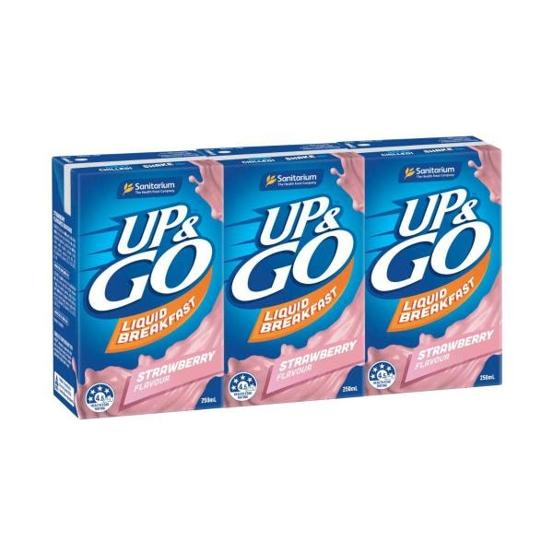

UP&GO Liquid Breakfast Strawberry 3x250ml | 750mL

$7.00
$9.33/ 1L
5 more buying options
Quantity
Liquid Breakfast Strawberry 3x250ml quantity is 1 item123456789101112
Remove from list
Product is not in your trolleyAdd
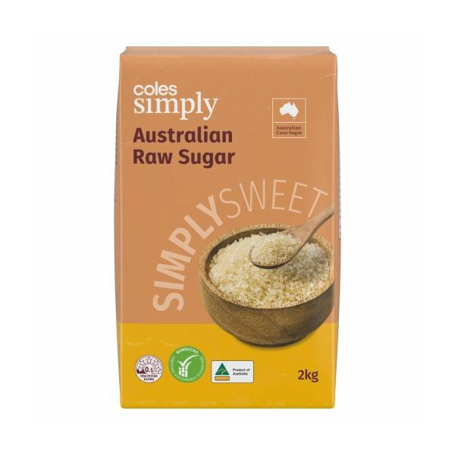
EVERY DAY

Coles Simply Australian Raw Sugar | 2Kg

$3.00
$0.15/ 100g
1 more buying option
Quantity
Australian Raw Sugar quantity is 1 item123456789101112
Remove from list
Product is not in your trolleyAdd

EVERY DAY

Wonder White Bread + Vitamins & Minerals | 700g

$4.60
$0.66/ 100g
2 more buying options
Quantity
White Bread + Vitamins & Minerals quantity is 1 item123456789101112
Remove from list
Product is not in your trolleyAdd
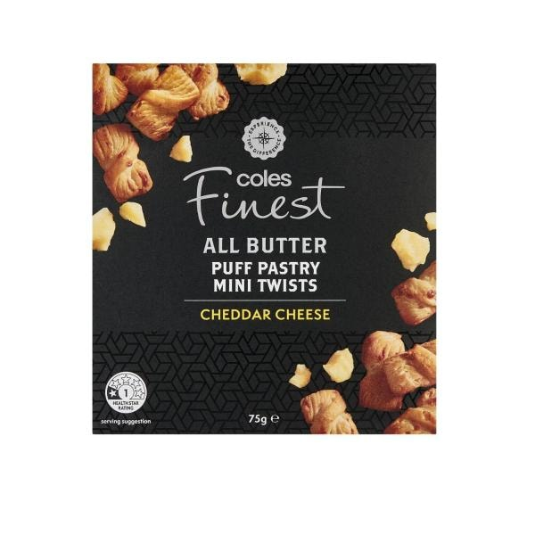

Coles Finest All Butter Puff Pastry Cheese Mini Twists Crackers | 75g

$2.50
$3.33/ 100g
Quantity
All Butter Puff Pastry Cheese Mini Twists Crackers quantity is 1 item1234567891011121314151617181920
Remove from list
Product is not in your trolleyAdd

SPECIAL

Jumpy's Chicken Potato Chips Multipack School Snacks 5 Pack | 90g

$4.00
$4.44/ 100g
Any 2 | $7
$3.89/ 100g
7 more buying options
Quantity
Chicken Potato Chips Multipack School Snacks 5 Pack quantity is 1 item123456789101112
Remove from list
Product is not in your trolleyAdd

SPECIAL

Daily Juice Pulp Free No Added Sugar Orange Juice | 500mL

$2.95
Save $0.60
$5.90/ 1L | Was $3.55
2 more buying options
Quantity
Pulp Free No Added Sugar Orange Juice quantity is 1 item123456789101112
Remove from list
Product is not in your trolleyAdd
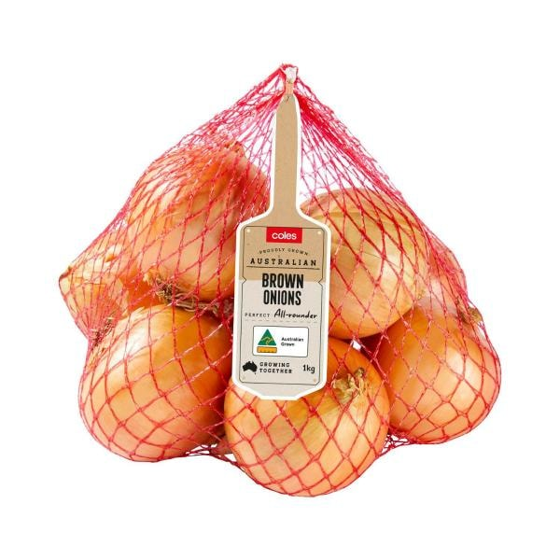

Coles Brown Onions | 1kg

$3.60
$3.60/ 1kg
Quantity
Brown Onions quantity is 1 item1234567891011121314151617181920212223242526272829303132333435363738394041424344454647484950
Remove from list
Product is not in your trolleyAdd
Bonus entry^See footnote

Sanitarium So Good Almond Milk Chocolate Uht | 1L

$3.50
$3.50/ 1L
4 more buying options
Quantity
So Good Almond Milk Chocolate Uht quantity is 1 item123456789101112
Remove from list
Product is not in your trolleyAdd
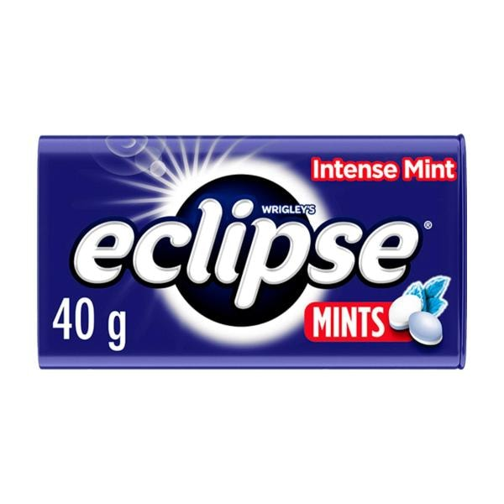
SPECIAL

Eclipse Intense Mint Sugar Free Mints Tin | 40g

$3.50
Save $0.50
$8.75/ 100g | Was $4.00
8 more buying options
Quantity
Intense Mint Sugar Free Mints Tin quantity is 1 item123456789101112
Remove from list
Product is not in your trolleyAdd
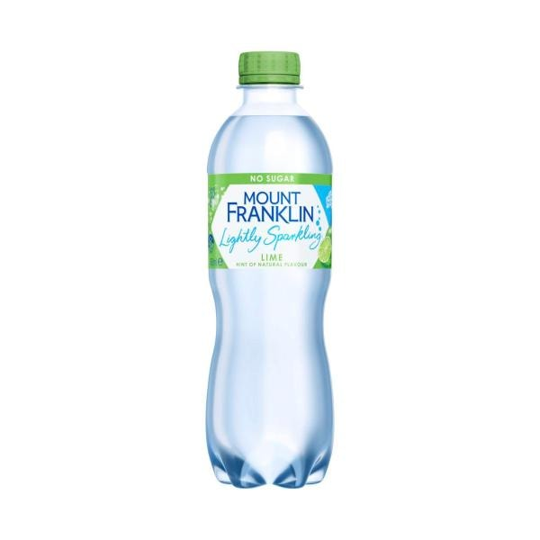

Mount Franklin Lightly Sparkling Water Lime Bottle | 450mL

Currently unavailable
Quantity
Lightly Sparkling Water Lime Bottle quantity is 1 item123456789101112131415161718192021222324
Remove from list
Shop similar
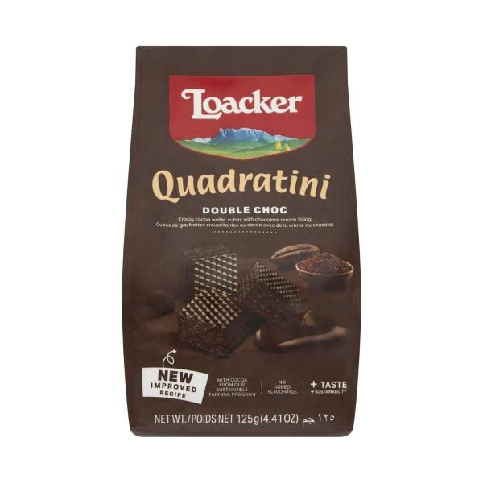

Loacker Quadratini Wafers Biscuits Double Choc | 125g

$3.30
$2.64/ 100g
Quantity
Quadratini Wafers Biscuits Double Choc quantity is 1 item1234567891011121314151617181920
Remove from list
Product is not in your trolleyAdd
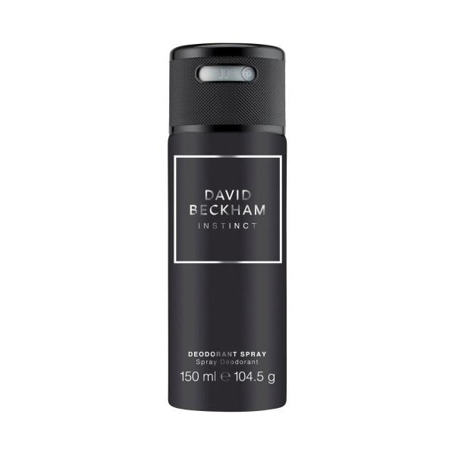

David Beckham Instinct Deodorant Body Spray | 150mL

$9.00
$6.00/ 100mL
Currently unavailable
Quantity
Instinct Deodorant Body Spray quantity is 1 item1234567891011121314151617181920
Remove from list
Shop similar
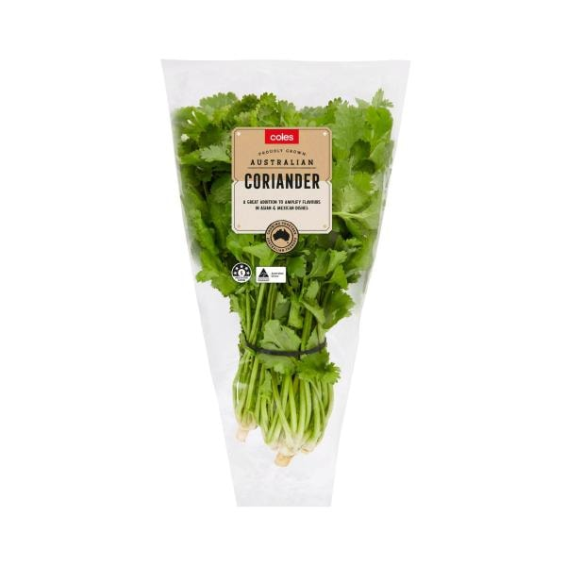
SPECIAL

Coles Sleeved Herbs Coriander | 1 Bunch

$3.30
$3.30/ 1ea
Any 2 | $6
$3.00/ 1ea
6 more buying options
Quantity
Sleeved Herbs Coriander quantity is 1 item1234567891011121314151617181920212223242526272829303132333435363738394041424344454647484950
Remove from list
Product is not in your trolleyAdd
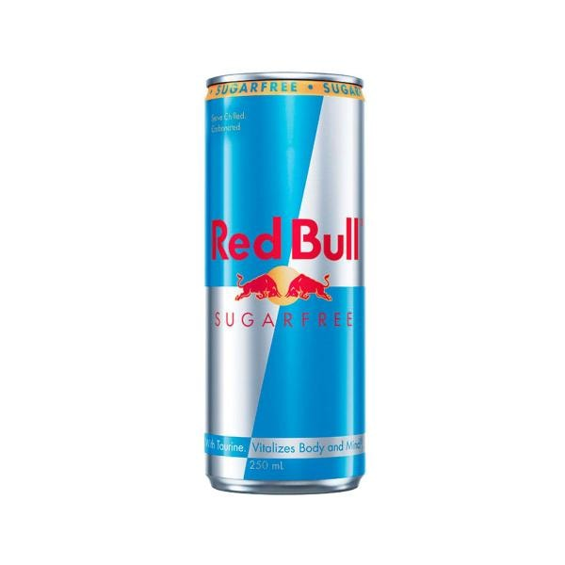
SPECIAL

Red Bull Sugar Free Energy Drink Single Can | 250mL

$3.20
$12.80/ 1L
Any 2 | $5.70
$11.40/ 1L
Quantity
Sugar Free Energy Drink Single Can quantity is 1 item123456789101112
Remove from list
Product is not in your trolleyAdd
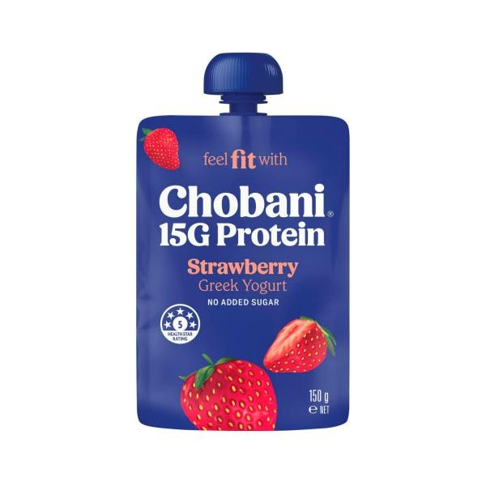

Chobani 15g High Protein Greek Yogurt Strawberry Pouch | 150g

$3.30
$2.20/ 100g
9 more buying options
Quantity
15g High Protein Greek Yogurt Strawberry Pouch quantity is 1 item1234567891011121314151617181920
Remove from list
Product is not in your trolleyAdd

SPECIAL

Red Rock Deli Chips Spicy Chilli Sriracha | 165g

$6.00
$3.64/ 100g
Any 2 | $8
$2.42/ 100g
Quantity
Spicy Chilli Sriracha quantity is 1 item123456789101112
Remove from list
Product is not in your trolleyAdd
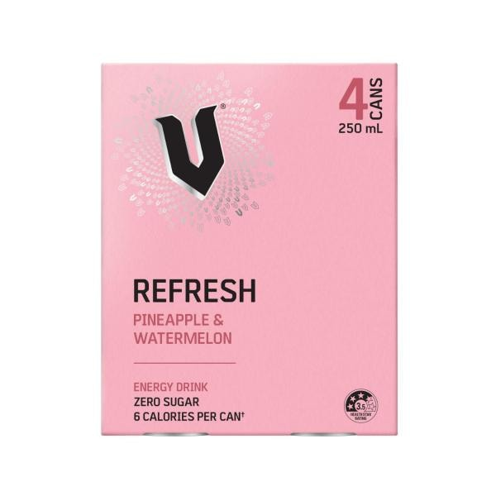
SPECIAL

V Energy Drink Pineapple 4x250ml | 1L

$7.20
Save $4.80
$7.20/ 1L | Was $12.00
Quantity
Energy Drink Pineapple 4x250ml quantity is 1 item123456789101112
Remove from list
Product is not in your trolleyAdd

EVERY DAY

V Energy Zero Sugar Original | 250mL

$2.65
$10.60/ 1L
Quantity
Zero Sugar Original quantity is 1 item123456789101112
Remove from list
Product is not in your trolleyAdd

Coles Spring Onions | 1 Bunch

$3.00
$3.00/ 1ea
Quantity
Spring Onions quantity is 1 item1234567891011121314151617181920212223242526272829303132333435363738394041424344454647484950
Remove from list
Product is not in your trolleyAdd

EVERY DAY

Hot Hands Hand Warmers | 2 Pack

$2.50
$1.25/ 1ea
Quantity
Hand Warmers quantity is 1 item123456789101112
Remove from list
Product is not in your trolleyAdd

EVERY DAY

Mount Franklin Spring Water Bottle | 600mL

$2.55
$4.25/ 1L
2 more buying options
Quantity
Spring Water Bottle quantity is 1 item123456789101112
Remove from list
Product is not in your trolleyAdd
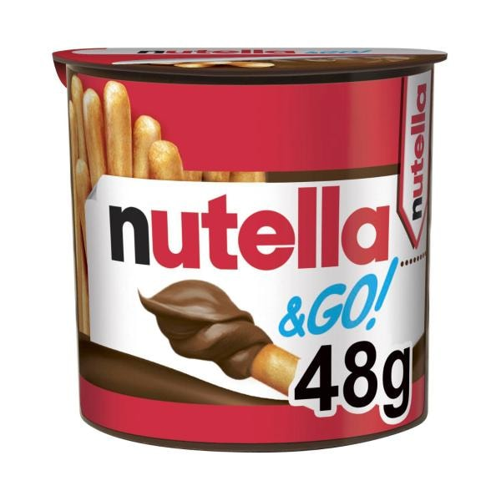
ONLINE ONLY

Nutella & Go With Breadsticks | 48g

$2.00
Save $0.80
$4.17/ 100g | Was $2.80
Quantity
& Go With Breadsticks quantity is 1 item123456789101112
Remove from list
Product is not in your trolleyAdd
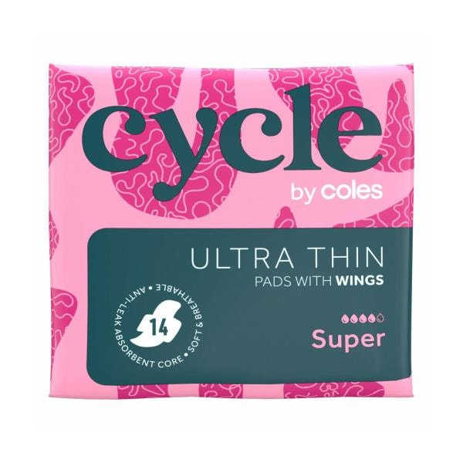
EVERY DAY

Cycle By Coles Pads Ultra Thin Super Wings | 14 Pack

$2.20
$0.16/ 1ea
2 more buying options
Quantity
Pads Ultra Thin Super Wings quantity is 1 item123456789101112
Remove from list
Product is not in your trolleyAdd
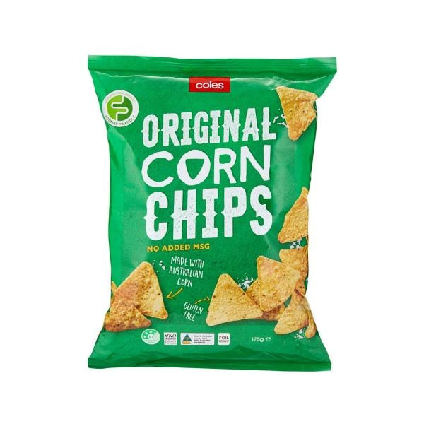
EVERY DAY

Coles Corn Chips Original | 175g

$2.20
$1.26/ 100g
Quantity
Corn Chips Original quantity is 1 item123456789101112
Remove from list
Product is not in your trolleyAdd
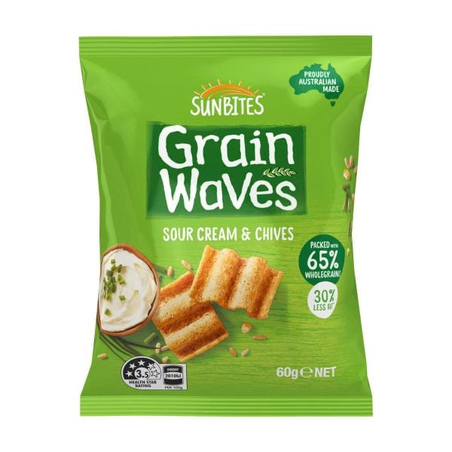
SPECIAL

Sunbites Grainwaves Sour Cream & Chive | 60g

$2.70
$4.50/ 100g
Any 2 | $4
$3.33/ 100g
Quantity
Grainwaves Sour Cream & Chive quantity is 1 item123456789101112
Remove from list
Product is not in your trolleyAdd
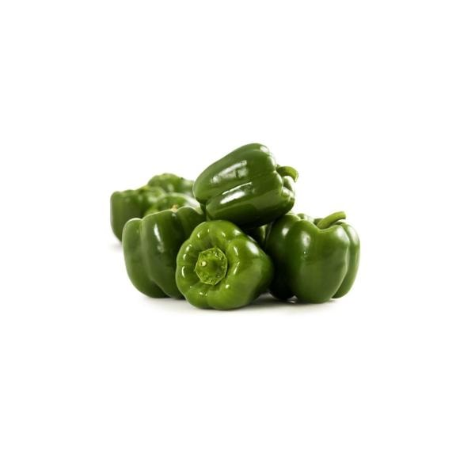
SPECIAL

Coles Capsicum Green Loose | approx. 220g

$1.30
$5.90/ 1kg
Final price is based on weight
Quantity
Capsicum Green Loose quantity is 1 item1234567891011121314151617181920212223242526272829303132333435363738394041424344454647484950
Remove from list
Product is not in your trolleyAdd
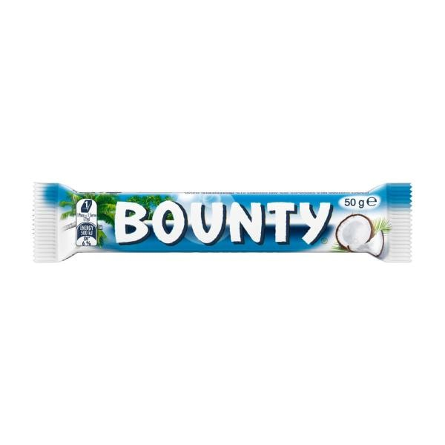
SPECIAL

Bounty Coconut Chocolate Bar | 50g

$3.00
$6.00/ 100g
Any 2 | $5
$5.00/ 100g
Quantity
Coconut Chocolate Bar quantity is 1 item123456789101112
Remove from list
Product is not in your trolleyAdd
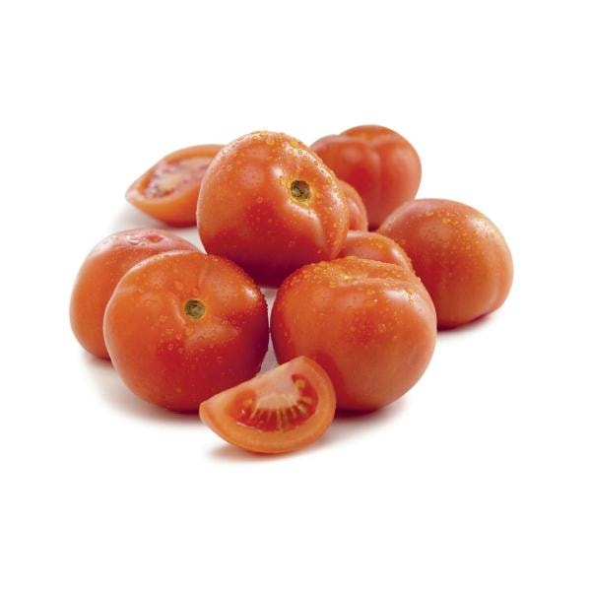
SPECIAL

Coles Tomatoes Gourmet | approx. 130g

$0.64
$4.90/ 1kg
Final price is based on weight
Quantity
Tomatoes Gourmet quantity is 1 item1234567891011121314151617181920212223242526272829303132333435363738394041424344454647484950
Remove from list
Product is not in your trolleyAdd
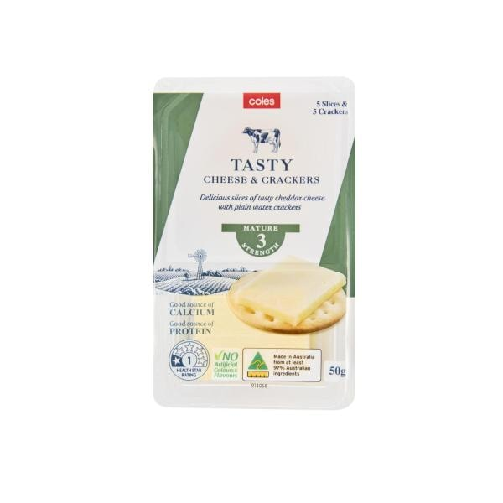
EVERY DAY

Coles Tasty Cheese & Crackers | 50g

$2.00
$4.00/ 100g
Quantity
Tasty Cheese & Crackers quantity is 1 item123456789101112
Remove from list
Product is not in your trolleyAdd
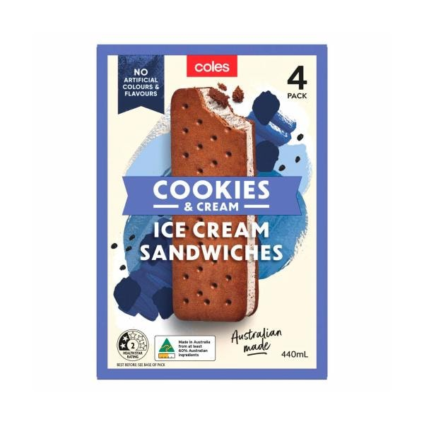
EVERY DAY

Coles Cookies & Cream Ice Cream Sandwich 4 Pack | 440mL

$3.80
$0.86/ 100mL
1 more buying option
Quantity
Cookies & Cream Ice Cream Sandwich 4 Pack quantity is 1 item123456789101112
Remove from list
Product is not in your trolleyAdd
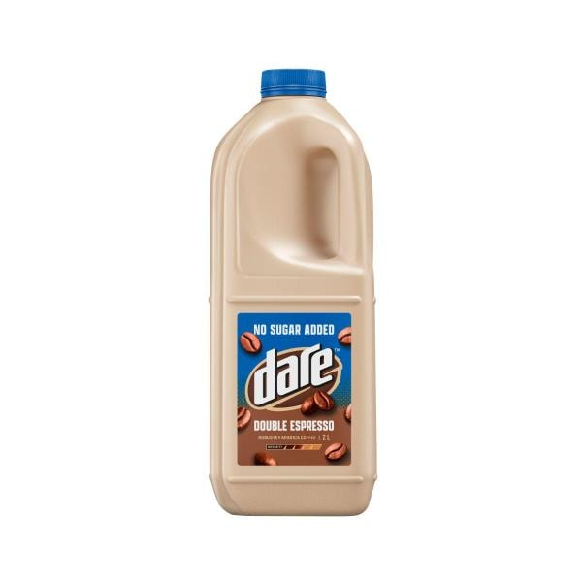

Dare No Sugar Added Iced Coffee Double Espresso | 2L

$7.70
$3.85/ 1L
5 more buying options
Quantity
No Sugar Added Iced Coffee Double Espresso quantity is 1 item1234567891011121314151617181920
Remove from list
Product is not in your trolleyAdd

Duracell Optimum AAA Alkaline Batteries | 10 Pack

$23.00
$2.30/ 1ea
2 more buying options
Quantity
Optimum AAA Alkaline Batteries quantity is 1 item1234567891011121314151617181920
Remove from list
Product is not in your trolleyAdd
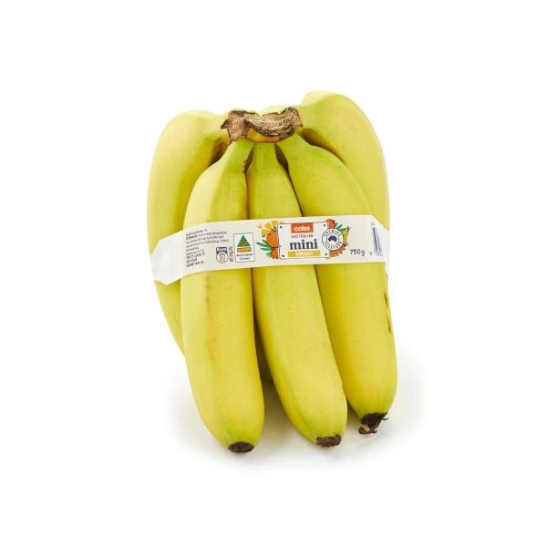

Coles Bananas Mini Pack | 750g

$4.90
$6.53/ 1kg
Quantity
Bananas Mini Pack quantity is 1 item1234567891011121314151617181920212223242526272829303132333435363738394041424344454647484950
Remove from list
Product is not in your trolleyAdd
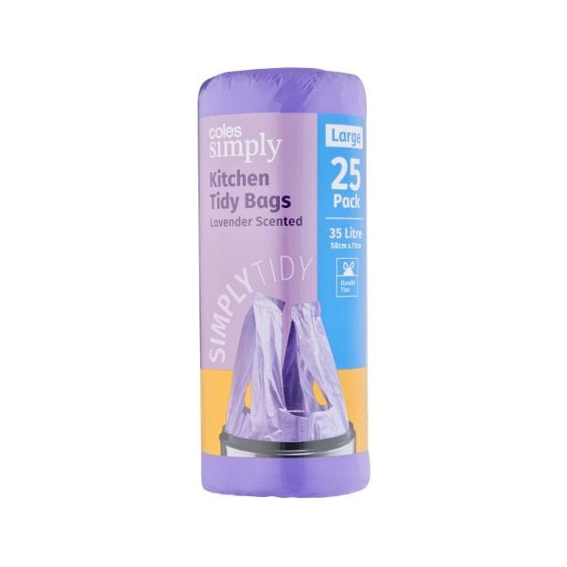

Coles Simply Kitchen Tidy Bags Lavendar Scented Large | 25 Pack

$2.25
$0.09/ 1ea
2 more buying options
Quantity
Kitchen Tidy Bags Lavendar Scented Large quantity is 1 item1234567891011121314151617181920
Remove from list
Product is not in your trolleyAdd
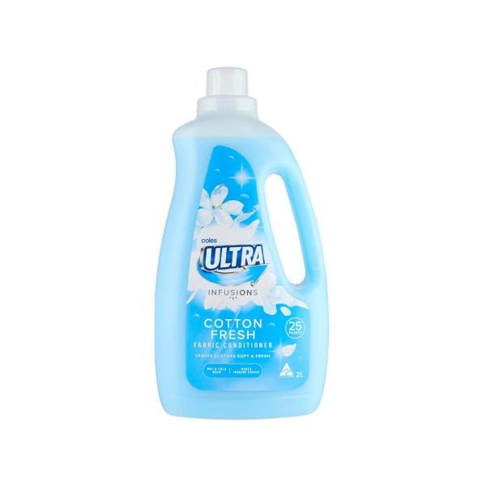
EVERY DAY

Coles Ultra Fabric Conditioner Cotton Fresh | 2L

$3.00
$1.50/ 1L
3 more buying options
Quantity
Fabric Conditioner Cotton Fresh quantity is 1 item123456789101112
Remove from list
Product is not in your trolleyAdd
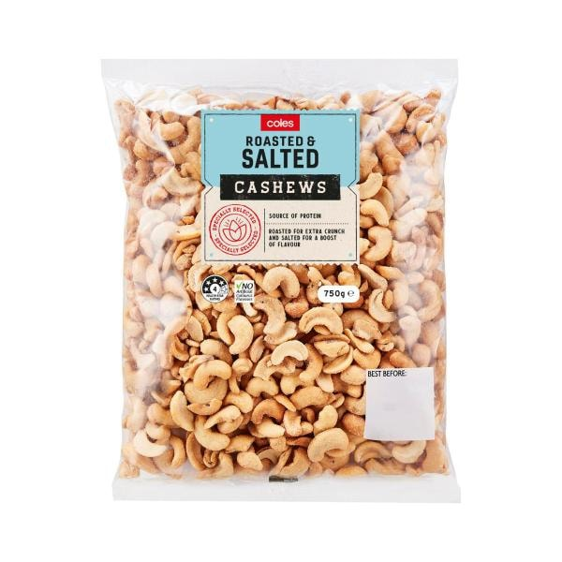

Coles Roasted And Salted Cashews | 750g

$16.00
$21.33/ 1kg
Quantity
Roasted And Salted Cashews quantity is 1 item1234567891011121314151617181920
Remove from list
Product is not in your trolleyAdd
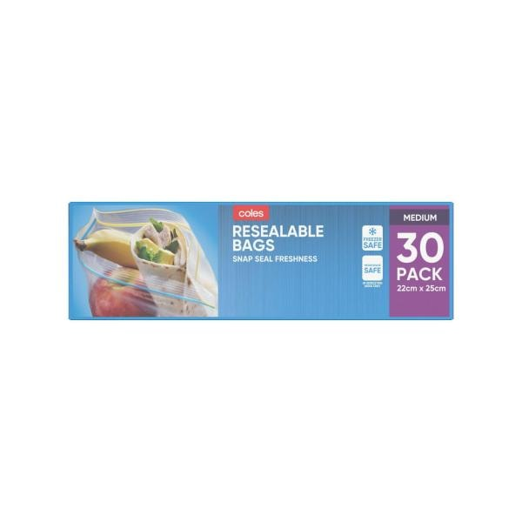
EVERY DAY

Coles Medium Resealable Storage Bags | 30 Pack

$2.80
$0.09/ 1ea
3 more buying options
Quantity
Medium Resealable Storage Bags quantity is 1 item123456789101112
Remove from list
Product is not in your trolleyAdd
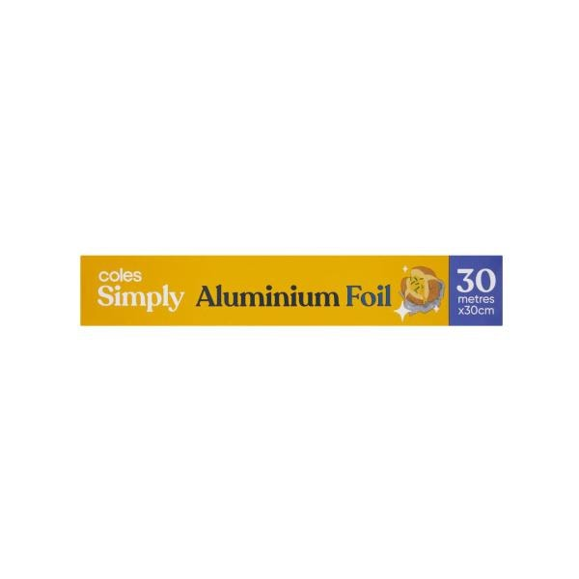

Coles Simply Aluminium Foil | 30M

Currently unavailable
Quantity
Aluminium Foil quantity is 1 item123456789101112131415161718192021222324
Remove from list
Shop similar
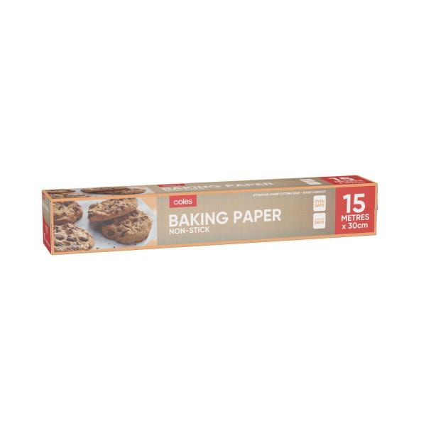

Coles Non Stick Baking Paper | 15m

Currently unavailable
Quantity
Non Stick Baking Paper quantity is 1 item123456789101112131415161718192021222324
Remove from list
Shop similar
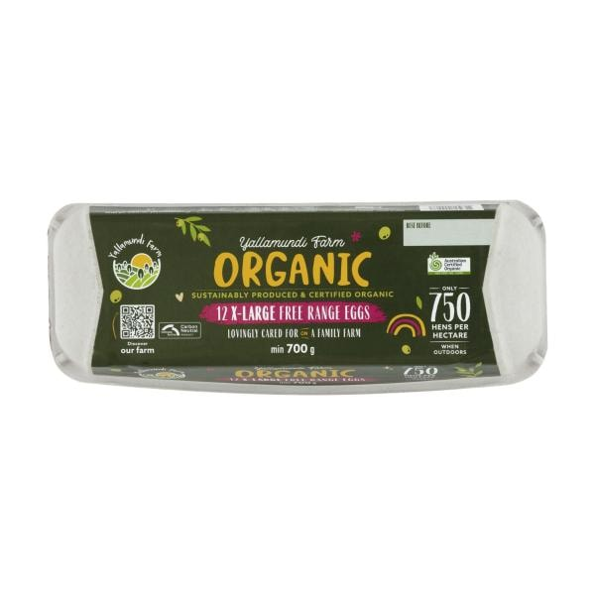

Yallamundi Farm Organic Free Range Eggs 12 Pack | 700g

$14.30
$2.04/ 100g
1 more buying option
Quantity
Organic Free Range Eggs 12 Pack quantity is 1 item1234567891011121314151617181920
Remove from list
Product is not in your trolleyAdd
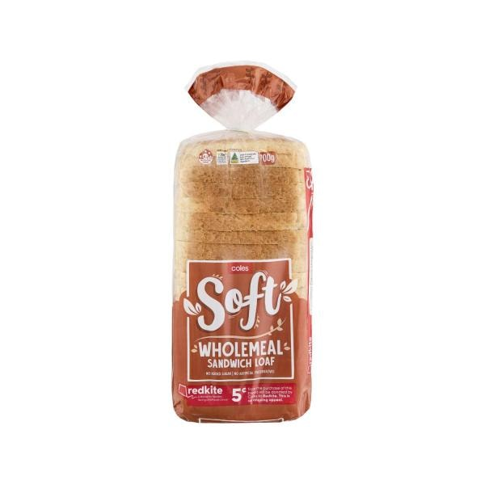

Coles Soft Wholemeal Sandwich Loaf | 700g

$2.80
$0.40/ 100g
4 more buying options
Quantity
Soft Wholemeal Sandwich Loaf quantity is 1 item1234567891011121314151617181920
Remove from list
Product is not in your trolleyAdd
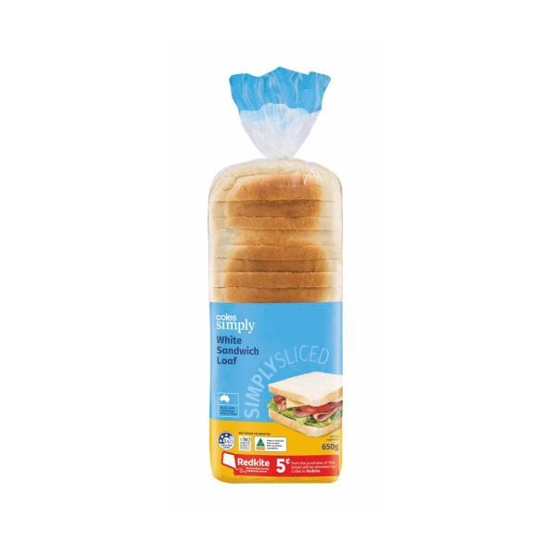
EVERY DAY

Coles Simply White Sandwich Loaf | 650g

$2.50
$0.38/ 100g
Quantity
White Sandwich Loaf quantity is 1 item123456789101112
Remove from list
Product is not in your trolleyAdd

Coles Full Cream Milk | 3L

$5.15
$1.72/ 1L
18 more buying options
Quantity
Full Cream Milk quantity is 1 item1234567891011121314151617181920
Remove from list
Product is not in your trolleyAdd
Customer help
- Contact us
- Help Centre
- Staying safe online
- Returns & refunds
- Product recalls
- Accessibility
Useful links
- Stores near you
- Browse Products
- Coles magazines
- Gift cards
- Coles Radio
- Coles Plus
Free trial

- Competition winners
About Coles
- Introducing us
- Our brands
- Careers
- Our history
- Sustainability at Coles
- Media releases
- Investor information
- How Flybuys works
Follow us

Download the Coles app

Explore our brands

^Competition dates 12/8/26 to 22/9/26. Open to AU res. 18yrs+ and a registered Flybuys member. Limit of three (3) bonus entries applies per brand, per transaction. A limit of one prize per day per Flybuys account applies for instore transactions only. Prize money can be used instore only and available to redeem until 30/11/26. Excludes the purchase of iTunes cards, gift cards, Mobile and Tech accessories (inc. plans and recharge), Opal top up, calling cards, charity products, tobacco and tobacco related product purchases. Full T&Cs apply. ACT Permit TP26/01179 NSW Permit NTP/16989 SA Permit T26/911.

No alcohol can be sold or supplied to anyone under 18. It's against the law. It's an offence to supply liquor to a person under the age of 18 years. All liquor products are sold and supplied by Liquorland (Australia) Pty Ltd. For more specific legislation in your state or territory, and to view our liquor and tobacco licences, visit our help page. To voluntarily exclude yourself from being able to purchase liquor online at Coles, please contact us.
- Privacy policy
- Terms and conditions
- Customer agreement
- Sitemap
Coles Online - Hawthorn East, Victoria Australia 3123 © Copyright Coles 2026
My Shopping Lists | Coles
Need help?

